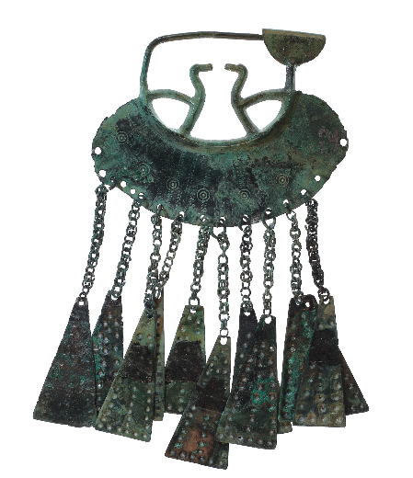
Conference registration form

5th International Conference 2024
Early Iron Age in Central Europe

Date: 1–3 July 2024 in Linz (AT)
Venue: Linz Schlossmuseum/Castle Museum, Schlossberg 1, 4020 Linz
Please, fill in the form below to register for participation in the conference. The conference fee amounts to € 50 and € 25 for students and covers excursion expenses, conference materials, and coffee breaks.
If you are submitting an abstract/poster, please note that you should also send your abstract or poster via email to team@orbisferrorum.com. The call for submissions closes on 22 April 2024; the deadline for registration is on 7 June 2024.
Contact information
First name* Last name*
______________________ ________________________________
E-Mail*: _______________________________________
Phone number: _______________________________________
Primary affiliation: *
_________________________________________________________________
Affiliation:
______________________________________________________________________________
______________________________________________________________________________
Postal code: ____________ City: ________________________Country: _________________
Correspondence address:
______________________________________________________________________________
______________________________________________________________________________
Postal code: ____________ City: ________________________Country: _________________

Which address is to be published in conference materials?
____ institution’s address
____ private address
____ none

I wish my e-mail address to be published in conference materials:
____ YES
____ NO

Abstract (max. 300 words):
Conference participation*
Oral presentation: ___ YES ___ NO
Title: ______________________________________________________________________________
____________________________________________________________________________________
Poster: ___ YES ___ NO
Title: ______________________________________________________________________________
____________________________________________________________________________________
In case of multiple co-authors, we kindly ask you to indicate the main author/speaker and fill in separate registration forms for all the other authors so that their names and affiliations can be published in the conference materials if wished.

Conference fee type*
___ regular participant
___ student
The fee can be paid upon arrival or via bank transfer prior to the conference. The fee must be credited to the account by 28 June at the latest.
Account holder: Orbis Ferrorum
Raiffeisenbank Bruck-Carnuntum
IBAN: AT65 3207 3000 0088 1151
BIC: RLNWATWWBRL
Payment reference: Conference fee, NAME

Conference event registration*
The conference comprises two days of presentations and a one-day excursion. Posters are presented during the breaks. Social evenings are organised from Sunday to Tuesday.
Please select the events you will be attending:
____ Sunday, 30 June 2024: Get-together “Welcome to Linz” at Stiegl-Klosterhof
____ Monday, 1 July 2024 at 19:30: Social evening
____ Tuesday, 2 July 2024 at 19:30: Social evening
____ Wednesday, 3 July 2024: One-day excursion to selected sites in Upper Austria
A preliminary programme can be found here: https://orbisferrorum.com/eia-conference-2024
.

Message to the organising committee

Data privacy
Consent to the production and use of image/photo/video recordings:
I hereby give my consent to being photographed during the event. I also agree to the further use of these images for the purpose of public information. The images taken may be published online and in local media.
I do not derive any rights (e.g. payment) from this consent. A cancellation can be sent at any time to team@orbisferrorum.com. In the event of cancellation, the images will be archived or removed from the website. There will be no further use.
___ YES ___ NO
Acknowledgement to the use of private data by the organising committee:
I acknowledge that my personal data (name, address, e-mail address, phone number) is to be used for the purpose of organising the conference. My data is not passed on to third parties.
___ YES ___ NO

Accommodation
Do you require accommodation? ___ YES ___ NO

Signature: ____________________________________ Date: _____________________

Contact:
Mag. Claudia Panenka, BA
Orbis Ferrorum, A. Baumgartnerstraße 44, 1230 Vienna
team@orbisferrorum.com

